**Installing Agent Console App (version 0.0)**

1. Create a directory under the root directory such as *c:\palette\agent*
2. Using 7-Zip or Windows Zip, unzip the files from the zipped package into the *agent* directory (alternatively, if pulling the files from source control, copy the files from *C:\Palette\agent\ConsoleAgent\bin\Debug* into *c:\palette\agent*)

The zip package should contain the following files:

* *ConsoleAgent.exe*
* *fastJSON.dll*

1. Right click on the file *ConsoleAgent.exe* and select “create shortcut”. A file with the name “*ConsoleAgent.exe -shortcut*” will be created in the same folder. Place the shortcut in *C:\ProgramData\Microsoft\Windows\Start Menu\Programs\Startup* (if the Startup folder is not located here, go to the Start button, right click on “All Programs”, and choose “Open all users”, double click on “Programs” and double click on “Startup” to open the Startup folder.
2. When Windows is rebooted, *ConsoleAgent.exe* will open in a Console window and listen on port 8888:  
     
   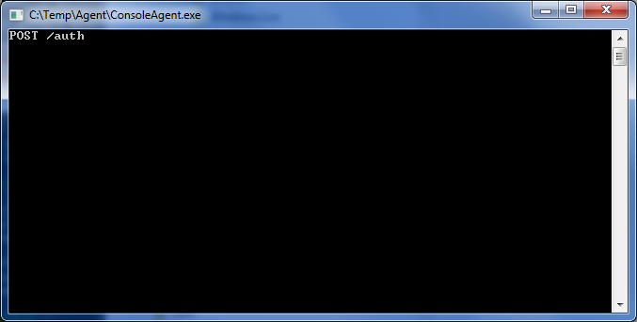
3. When the Controller is running and connected to the same ip address and port, it will send a request and receive a response from the Agent, displaying a DEBUG statement with a JSON body indicating the version of Agent and the hostname, ip, username, password, etc.:

